# CS 255 System Design Document

## UML Diagrams

### UML Use Case Diagram

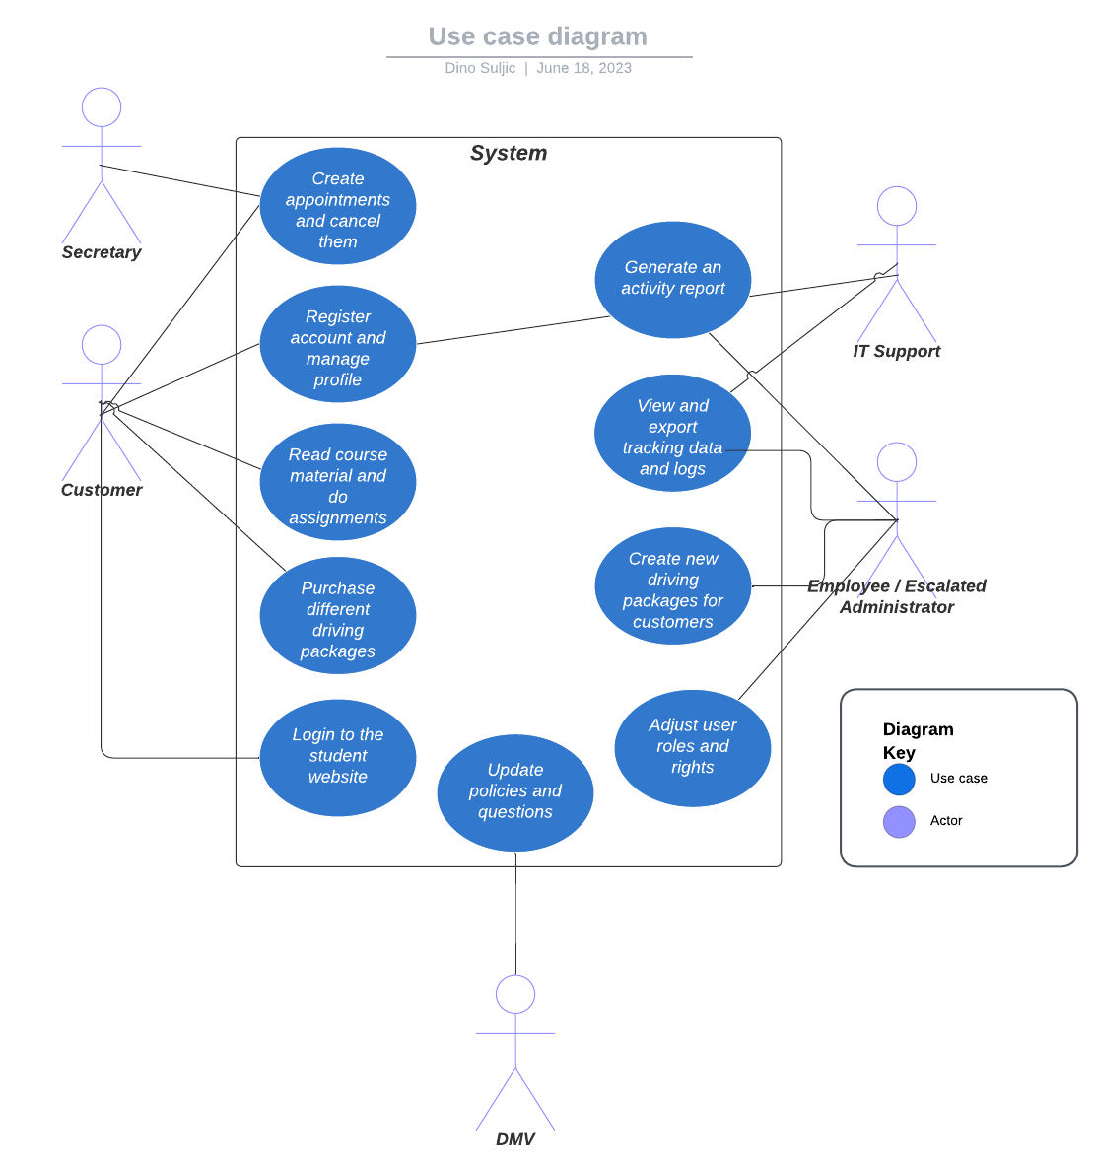

### UML Activity Diagrams

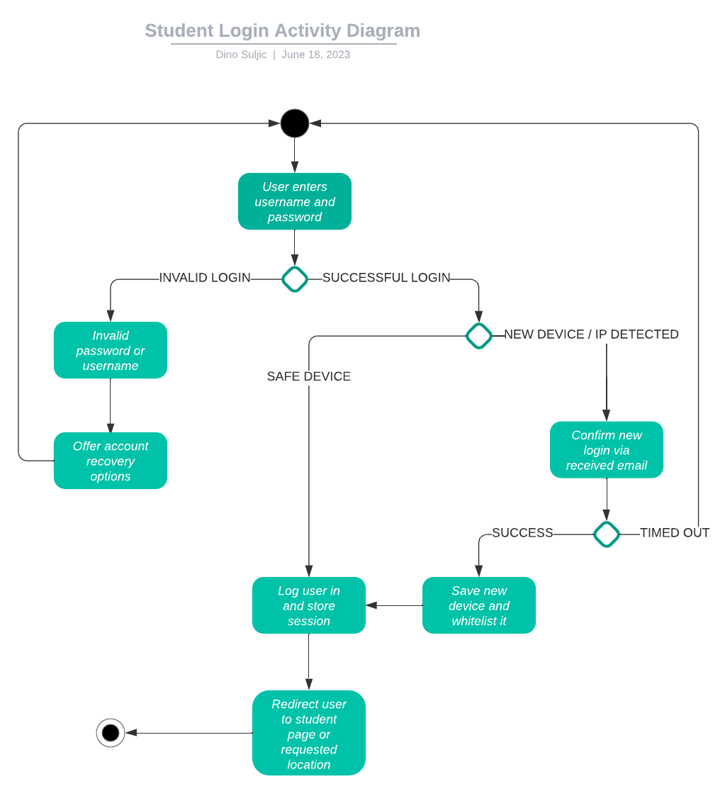

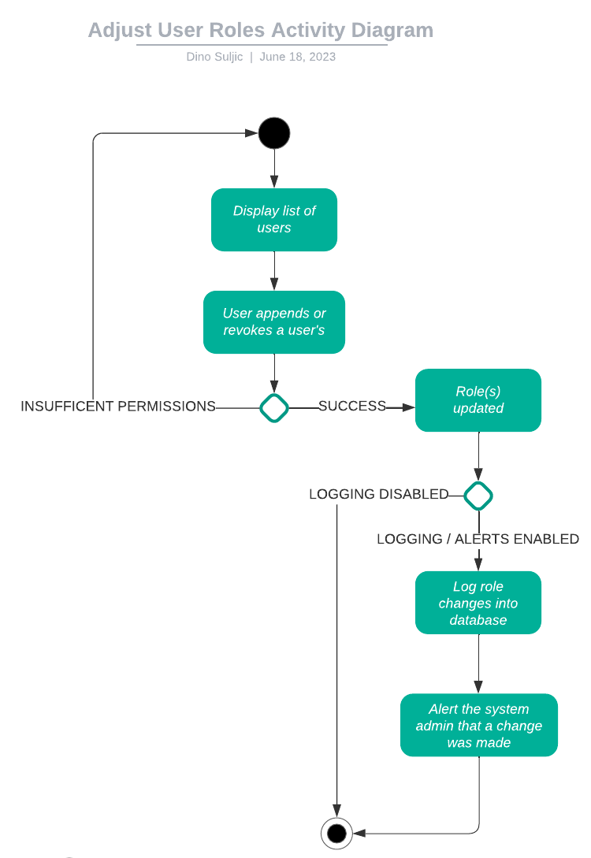

### UML Sequence Diagram

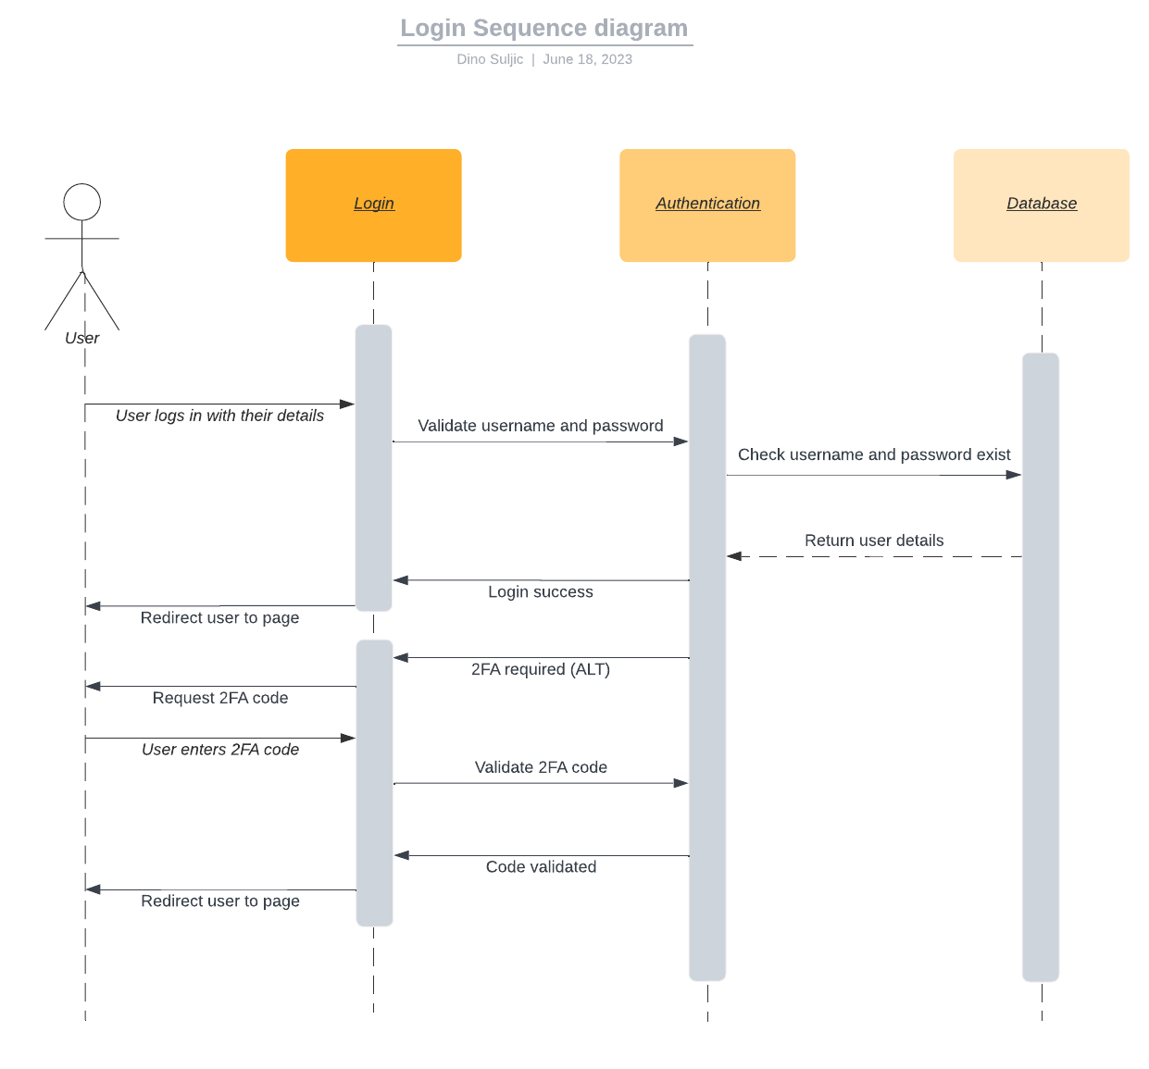

### UML Class Diagram

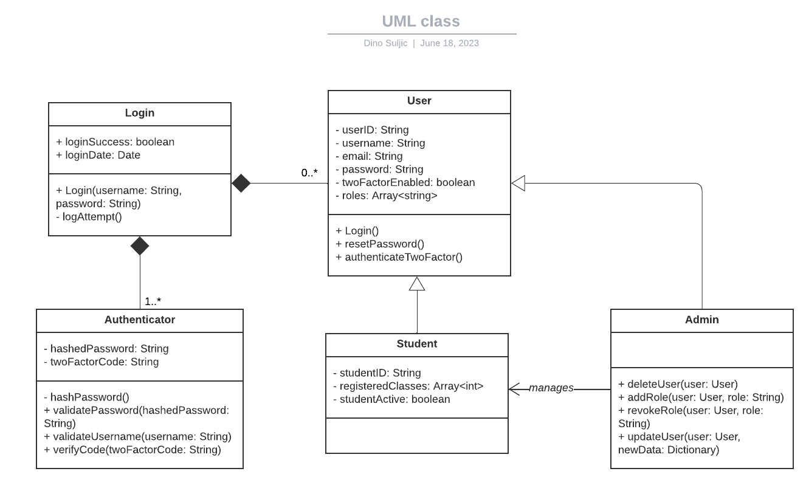

## Technical Requirements

* To use the system, a user must have a device that has a browser and is capable of accessing the internet.
* The backend must also be hosted on a server that is capable of running 24/7 and serving data to multiple clients.
* The system must support a data serialization format for data exchange, most likely JSON.
* The system must have a SSL certificate since we’re dealing with authentication.
* The system must support page redirects.
* The system must be efficient and be able to make HTTP requests within a reasonable amount of time, such as <10 seconds at worst.